# Applying filters to SQL queries

## Project description

My organization is working to enhance the security of our system. My responsibilities include ensuring the system's safety, investigating potential security issues, and updating employee computers as necessary.

## Retrieve after hours failed login attempts

The following code demonstrates how I created an SQL query to filter for failed login attempts that occurred after business hours:

**SELECT \***

**FROM log_in_attempts**

**WHERE login_time > ‘18:00’ AND success = FALSE;**

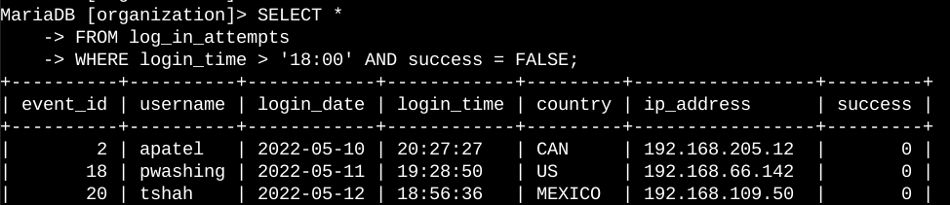

My responsibilities include ensuring the system's safety, investigating potential security issues, and updating employee computers as necessary. Below are examples of how I utilized SQL with filters to perform security-related tasks.

Retrieve After-Hours Failed Login Attempts

A potential security incident occurred outside of regular business hours (after 18:00). It is necessary to investigate all failed login attempts that occurred after hours

## Retrieve login attempts on specific dates

A suspicious event occurred on 2022-05-09. Any login activity that happened on 2022-05-09 or on the day before needs to be investigated.

The following code demonstrates how I created an SQL query to filter for login attempts that occurred on specific dates:

**SELECT \***

**FROM log_in_attempts**

**WHERE DATE(login_time) IN ('2022-05-08', '2022-05-09');**

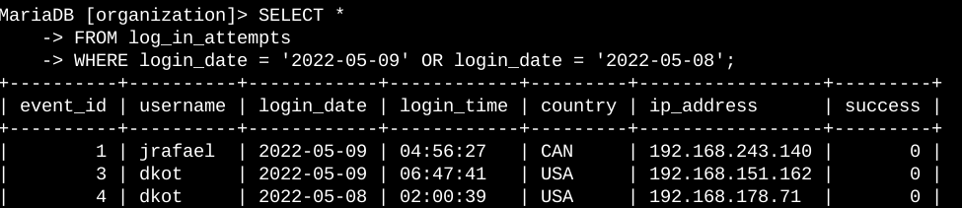

The first part of the screenshot is my query, and the second part is a portion of the output. This query returns all login attempts that occurred on 2022-05-09 or 2022-05-08. First, I started by selecting all data from the log_in_attempts table. Then, I used a WHERE clause with an OR operator to filter my results to output only login attempts that occurred on either 2022-05-09 or 2022-05-08. The first condition is login_date = '2022-05-09', which filters for logins on 2022-05-09. The second condition is login_date = '2022-05-08', which filters for logins on 2022-05-08.

## Retrieve login attempts outside of Mexico

After investigating the organization’s data on login attempts, I believe there is an issue with the login attempts that occurred outside of Mexico. These login attempts should be investigated.

The following code demonstrates how I created a SQL query to filter for login attempts that occurred outside of Mexico.

**SELECT \***

**FROM log_in_attempts**

**WHERE NOT country LIKE ‘MEX%’;**

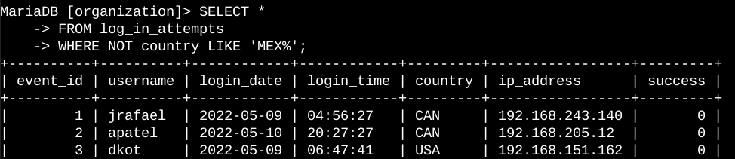

This query returns all login attempts that occurred in countries other than Mexico. First, I started by selecting all data from the log_in_attempts table. Then, I used a WHERE clause with NOT to filter for countries other than Mexico. I used LIKE with MEX% as the pattern to match because the dataset represents Mexico as MEX and MEXICO. The percentage sign (%) represents any number of unspecified characters when used with LIKE.

## Retrieve employees in Marketing

My team wants to update the computers for certain employees in the Marketing department. To do this, I have to get information on which employee machines to update.

The following code demonstrates how I created a SQL query to filter for employee machines from employees in the Marketing department in the East building.

**FROM employees**

**WHERE department = ‘Marketing’ AND office LIKE ‘EAST%’;**

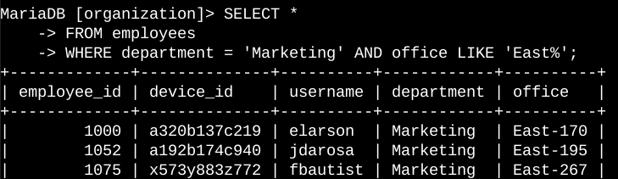

This query returns all employees in the Marketing department in the East building. First, I started by selecting all data from the employees table. Then, I used a WHERE clause with AND to filter for employees who work in the Marketing department and in the East building. I used LIKE with East% as the pattern to match because the data in the office column represents the East building with the specific office number. The first condition is the department = 'Marketing' portion, which filters for employees in the Marketing department. The second condition is the office LIKE 'East%' portion, which filters for employees in the East building.

## Retrieve employees in Finance or Sales

The machines for employees in the Finance and Sales departments also need to be updated. Since a different security update is needed, I have to get information on employees only from these two departments.

The following code demonstrates how I created a SQL query to filter for employee machines from employees in the Finance or Sales departments.

**FROM employees**

**WHERE department = ‘Finance’ OR department = ‘Sales’;**

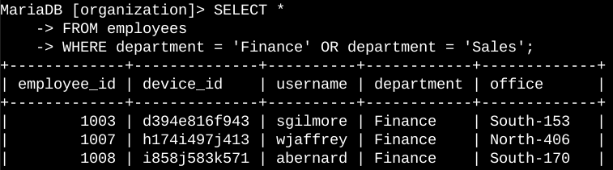

This query returns all employees in the Finance and Sales departments. First, I started by selecting all data from the employees table. Then, I used a WHERE clause with OR to filter for employees who are in the Finance and Sales departments. I used the OR operator instead of AND because I want all employees who are in either department. The first condition is department = 'Finance', which filters for employees from the Finance department. The second condition is department = 'Sales', which filters for employees from the Sales department.

## Retrieve all employees not in IT

My team needs to make one more security update on employees who are not in the Information Technology department. To make the update, I first have to get information on these employees.

The following demonstrates how I created a SQL query to filter for employee machines from employees not in the Information Technology department.

**FROM employees**

**WHERE NOT department = ‘Information Technology’;**

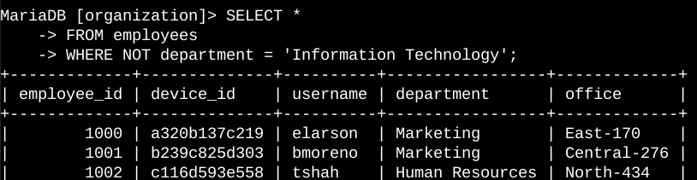

The first part of the screenshot is my query, and the second part is a portion of the output. The query returns all employees not in the Information Technology department. First, I started by selecting all data from the employees table. Then, I used a WHERE clause with NOT to filter for employees not in this department.

## Summary

I applied filters to SQL queries to get specific information on login attempts and employee machines. I used two different tables, log_in_attempts and employees. I used the AND, OR, and NOT operators to filter for the specific information needed for each task. I also used LIKE and the percentage sign (%) wildcard to filter for patterns.